Telford Playschool Responses 2014
The Telford Playschool Questionnaire for 2014 was sent out in January as it was felt this timing worked well for a greater percentage of carers. The questions remained almost unchanged, but an electronic survey format was used which saw an increase in response rate from 28 to 32 (an increase of 14%). Paper formats were offered to anyone unable to access a PC, but none were requested.
The results were once again full of praise and support for the excellent job done by staff, however there were a few concerns raised in the comments that have led to some recommendations for change to ensure the ongoing support and confidence of our parents/guardians following the committee meeting discussions.
A short overview of the responses with key recommendations and suggestions follows:
Q1a How easily did your child settle into Playschool?

The overwhelming majority (97%) of children settled "very easily" or "quite easily" into Playschool at Telford in 2014 against 93 % 2013, however there has been a reduction in the overall rate of “very easily” year on year.

Q2 Is there anything you think we can do to improve the settling in process?

75% of people felt there was nothing more we could do to improve the settling in process vs 86% in 2013.

The committee discussed the feedback but felt that Playschool does do everything it possibly can to assist children during this time, offering a wide variety of support and flexibility to assist the child irrespective of number of sessions attended.

Positive comments on settling in:
- “We liked the open door policy”
- “we've been really pleased with how well she has settled in and are impressed by the care shown by the staff.
- “Has always felt very relaxed and staff willing to work with different children’s needs”
Q3 Does your child enjoy their time at Playschool?

100% of children enjoy their time at playschool, another outstanding review from our most demanding of young clients.

Q4 Please ask your child what they think about playschool and write down their responses?

The children provided a wonderful selection of sound bites which can be used to promote Playschools offer for future attendees.

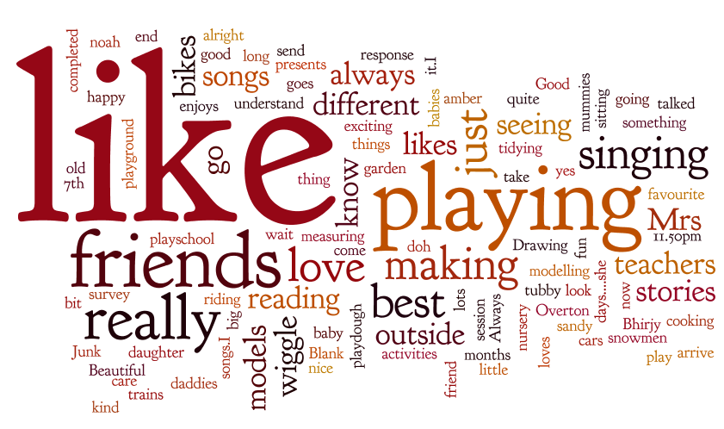

A few of the best:
- "I like it because I do"
- “I like my best friends best”
- “Because they always do something exciting like cooking and measuring. They always take care of me”
- “The best thing about playschool is only babies!”
- “I like trains, my teachers are kind!”
- “It's very nice. I really, really love it.I love playing. I love singing songs songs songs.I really like singing 5 tubby snowmen.”

Q4 Please ask you child what their favourite activity at Playschool is?

Play dough and model making were the children’s favourite activities followed by painting, playing with friends and drawing

Q6 Do you feel that you are kept informed about your child’s progress?

Overall there has been a year on year improvement in how informed parents feel about their child’s progress, although it was felt termly profiles could contain enhanced information to form an even clearer communication of observations and progress.

Q7 What do you feel playschool does well?

Overall it was felt that playschool met all of its key objectives well. Highest regard was for its friendly staff, safe environment and wide variety of activities. There was no change from the responses in 2013.

Q8 Have you any ideas of future improvements, fundraising suggestions or any other comments generally?
¾ of the respondents had no further comments, of those who did the main comments where requests for information about activities, planning and feedback. Here is a list of where to find the information you require:
Website – for general information about the Playschool, the committee, fundraising, policies, contact information | www.telfordplayschool.co.uk
Facebook group – for update information on activities and event, socialising with other parents, home learning information | Search for: Telford Playschool, group
Noticeboard outside Playschool | Daily planner (includes full details of daily activities), annual planner, current notices and events information
Noticeboard inside Playschool  (behind coat peg) | Staff details & photos, policies, annual planner, event information daily planner (includes full details of daily activities
Newsletter – issued half termly after committee meetings | Handed out in paper format on pick up. Contains news on current topics and activities, home learning information, events, songs, dates for diary.
Informal Feedback – at pick ups | Information relayed about child progress or activities or anything of significant note that day offered at pick ups . More detailed “formal ad hoc” feedback can be provided upon request at any time.
Formal Feedback – ad hoc | Available upon request from staff
Formal Feedback – Learning Review | Twice annually
Child Learning Journal | Available upon request from staff

Additional Comments:
Ensure children are pushed and not left having met age related expectations.
The Playschool learning environment is one of continually adaption of planning and assessment to meet the individual child’s need. No child is ever left, but neither are they pushed. Any parent with concerns about their child’s progress or development is advised to speak to a member of staff.
Healthy Eating Encouragement and Information
Healthy food and drinks options are the only ones on offer at Playschool and discussions on nutrition and food choices regularly take place. Cooking is undertaken as part of the education and experience whilst at Playschool and discussions about ingredients and keeping active form part of the normal topics covered
Model Making
Staff sit with children to discuss the process of and language involved with model making, to enjoy imaginative and creative play, often working in partnership with friends. The aim of the model is not based on the end result but on the process of making and the techniques employment to achieve that. Children are encouraged to explore and experiment whilst advise is given to support the learning.
Fund Raising Ideas
Lots of ideas were suggested and have been added to the fundraising planner for future use. Thank you. Please ensure you support Playschool fundraising activities as it is our only way to raise vital funds to provide the additional resources to support your children’s learning and education and of course FUN.
General:
- Very pleased with the Playschool, staff are committed and caring and there are plenty of different activities for the children to choose.
- My daughter has only just started. She is being well looked after and supported as she becomes more familiar with her environment. She is doing really well but I think will need some additional support for a while and I feel confident that her needs will be met, while her confidence grows.
Q9 Skills share

There were 3 offers for skills share from the respondents which are being followed up directly.

Q10 Match Funding

- One person who said they would contact Playschool directly.

Summary
In summary the feedback was hugely positive and useful and has highlighted several actions to be addressed. The questionnaire response information should be used within the classroom and on the website for promotional purposes.

2014 Recommendations
- Online survey format to be used in future years for ease of data collection, analysis and ease of access to all parents/guardians
- Welcome Pack refresh to contain additional information on settling in, staff and Playschool general practice and environment
- Termly Profile Page Updates to layout to aid parental understanding of observations and progress, plus and parents page sign off response to encourage 360 feedback
- Introduce password for non-regular pick ups for added layer of security
2013 Recommendations- UPDATE
- Some form of settling in information including daily activity planner example, staff introduction, term topics – In progress via updated welcome pack to follow
- Topics and talking points or even “A what we are doing today” to support and enhance learning at home – DONE via newsletter and planning sheets on noticeboard.
- Formalising feedback process – more detailed form or sit down review once or twice per year? – DONE Twice yearly parents evening offered.

